Chapter 11 Vitamins and proteins

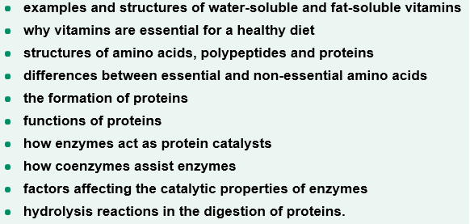

Test 11
Section A (20 marks)
1. Which of the following statements relating to food is incorrect?
A. the carbohydrates, fats and proteins contained in food all have varying energy contents
B. the digestion of food involves hydrolysis reactions
C. food is required to supply our energy needs for activities that occur during daylight hours
D. the chemical processes occurring in the body are collectively referred to as the body’s
metabolism

2. Which of the following statement about vitamins is incorrect? Vitamins
A. are essential for growth and nutrition
B. are either water-soluble or fat-soluble
C. A, D ,E and K can be absorbed in the small intestine and moved via the lymphatic system
D. vitamins have a relatively high energy content

3. Water soluble vitamins such as vitamin C
A. are stored in fat deposits in the body
B. cannot be stored in the body
C. contain few or no polar groups
D. consist mainly of the elements carbon and hydrogen

4. Proteins have many roles in the body. Which of the following roles is incorrect?
Proteins can
A. act as catalysts
B. assist with the formation of new molecules
C. coordinate biological processes between different cells
D. can supply the body with the majority of its energy needs.
5. Amino acids are the building blocks for the formation of proteins. The 20 amino acids that combine to form proteins in the body
A. have an amino group and a carboxyl group
B. form a solution with a pH of 7 when dissolved in water
C. all have polar R groups
D. can all be made by the body

6. The semi-structural formula of glycine in a solution of low pH is
A. H₂NCH₂COOH
B. H₃N⁺CH₂COO⁻
C. H₃N⁺CH₂COOH
D. H₂NCH₂COO⁻

7. The number of polypeptides that can form from 4 different amino acids is
A. 4
B. 6
C. 12
D. 24

8. The secondary structure of proteins is best described as involving the
A. the hydrogen bonding between amide links at different positions along the protein chain
B. the overall three dimensional shape of the protein
C. the number, type and sequence of amino acids in the polymer chain
D. the linking of individual protein molecules to form a particular spacial arrangement.

9. Which of the following statement about enzymes is incorrect? Enzymes
A. operate under mild conditions
B. are denatured at low temperatures
C. can only catalyse specific chemical reactions in the body
D. cause reactions to speed up millions of times

10. For proteins to be digested
A. the hydrogen bonds in the secondary and tertiary structures need to be broken
B. the peptide links need to react with water molecules
C. they need to form larger polypeptides which can be absorbed through the walls of the small
intestine
D. the pH of the digestive juices need to be greater than 7.

Section B (30 marks)
1. The diagram below shows monomer units in a section of a protein molecule.

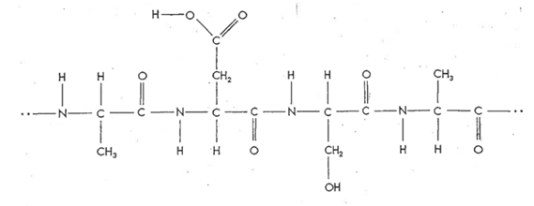
(a) Name the amino acids from which the above section of protein was formed.
(b) Name the type of reaction occurs when
(i) proteins are formed from amino acids and (ii) amino acids are formed from proteins
(c) Name two additional molecules that are involved in both (b)(i)(ii) above.
(d) Circle one peptide link on the above section of protein.
[3 + 2 + 2 + 1 = 8 marks]
2(a) Draw a structural isomer of the dipeptide shown below.
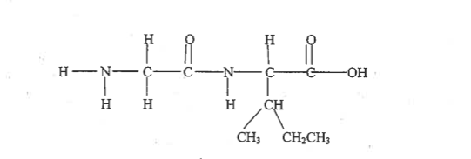
(b) Name the two amino acids that form this dipeptide.
[3 marks]

3.
(a) Use a semi-structural formula to show the structure of methionine in an aqueous solution with a pH = 10
(b) Use a semi-structural formula to show the zwitterionic form of glutamic acid
(c) Use structural formulas show the section of polypeptide chain described as
….. cys – asp – ala – val ……
[1 + 1 + 4 = 6 marks]

4(a) Circle and name the functional groups in the following vitamin
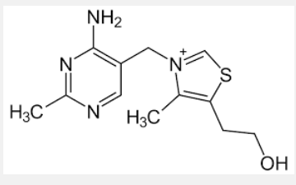
(b) Would you expect this vitamin to be water-soluble or fat-soluble? Explain your answwer
[3 + 2 = 5 marks]

5. The following diagram shows the four stages that describe the lock and key mechanism that is used to demonstrate how enzymes work.

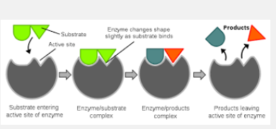

The lock and key mechanism comprises four stages which are described below in random order.
I. enzyme/substrate complex forms
II. products leave the active site of the enzyme
III. substrate enters the active site of the enzyme
IV. enzyme/product complex forms

(a) Identify which of the four stages shown in the diagram correspond to stages I, II, III and IV.

(b) On the diagram carefully label the
(i) enzyme
(ii) substrate
(iii) active site
(iv) products
[4 + 4 = 8 marks]

Solutions for test 11
Section A (20 marks)
1. C
2. D
3. B
4. D
5. A
6. C
7. D
8. A
9, B
10. B

Section B (30 marks) [marks are denoted by square brackets]
1(a) alanine, aspartic acid, serine [3]
(b)i) condensation []1
(ii) hydrolysis [1]
(c) water and enzymes [2]
(d)
[1]
< circle one of the 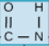 groups in the above section of protein >

2(a)
CH₃ CH₂CH₃
C H O
ǁ
H N C C N C C OH
ǁ
H H O H CH₃ [2]

(b) glycine and isoleucine [½ + ½ =1]

3(a) H₂NCH(CH₂CH₂SCH₃)COO⁻ [1]
(b) H₃N⁺CH(CH₂CH₂COOH)COO⁻ [1]
(c) <this group is fine >

[4x 1]
< make this group a CH₂SH > < make this group a CH₃ > <make this group a CH(CH₃)₂

4(a) an amino functional group


A methyl functional group a hydroxyl functional group [3]
<circle the 3 groups I have “boxed” >
(b) Water soluble because of the polar hydroxyl and amino functional groups as well as the positively charged section of the molecule. [2]

5(a)(b) <Leave the diagram exactly as is in these solutions (just add the I, II, III, IV as shown below)>
 [4]

III I IV II [4]

